**DYNAMIC PRICING**

**Phase 2 submission**

**College code: 9223**

**College Name: University College of Engineering, Dindigul.**

**Technology: AI**

**Total no of student in the group: 5**

**Student’s details within the group:**

**-->Hema.B**

**-->Harini.Y.A**

**-->Rohithkumar.S**

**-->Ajay.M**

**-->Saranya Dheve.B**

**Submitted by,** Y.A.Harini

aut388617

**Phase 2 Document: Data wrangling and Analysis on Dynamic pricing dataset Introduction:**

Dynamic pricing has revolutionized the way businesses approach pricing strategies by enabling real-time adjustments based on various factors. In today's fast-paced markets, static pricing models often fall short in capturing the complexities of demand fluctuations, competitor actions, and customer behavior. Dynamic pricing offers a solution by leveraging data analytics and technology to optimize prices continuously.

In this introduction, we'll explore the fundamentals of dynamic pricing and outline key considerations for implementing a dynamic pricing strategy effectively. From defining objectives to measuring performance, each step plays a crucial role in the success of a dynamic pricing project.

## Objectives:

The provided task involves four main steps:

1. **Data Cleansing:** Identify and rectify inconsistencies, errors, and missing values in the dataset to ensure data integrity.
2. **Exploratory Data Analysis (EDA):** Investigate dataset characteristics through visualizations and statistical methods to understand distributions and correlations among variables.
3. **Feature Engineering:** Enhance model performance by creating new features or transforming existing ones based on insights gained from EDA.
4. **Documentation:** Document the data wrangling process comprehensively, ensuring transparency and reproducibility by recording steps taken, providing clear explanations, and promoting reliability through structured documentation.

These steps collectively contribute to preparing the dataset for accurate

analysis and modeling while maintaining transparency and reproducibility in the process.

**Dataset Description:**

The dataset comprises historical pricing data, customer purchase history, market trends, and competitor pricing information.

**Data wrangling Techniques for Dynamic Pricing Dataset:**

#### 1. Data Description:

The instructions outline methods for initial data exploration and understanding:

1. **Head:** Shows the first few rows of data for a quick overview of its structure and content.
2. **Tail:** Displays the last few rows to ensure dataset completeness and consistency, especially regarding ordering and formatting.
3. **Info:** Provides details about the dataset's structure, data types, and memory usage, offering insights into its composition and characteristics.
4. **Describe:** Generates descriptive statistics for numerical features, summarizing key statistical measures to understand data distribution and variability.

These methods collectively enable analysts to gain a thorough understanding of the dataset, facilitating further analysis and modeling.

##### Python code:

# Sample code for pricing data description

import pandas as pd

pricing_data=pd.read_csv('/content/drive/MyDrive/AI/dynamic_pricing.csv')

print(pricing_data.head()) print(pricing_data.tail()) print(pricing_data.info()) print(pricing_data.describe())

##### Output:

|  |
| --- |
|  |

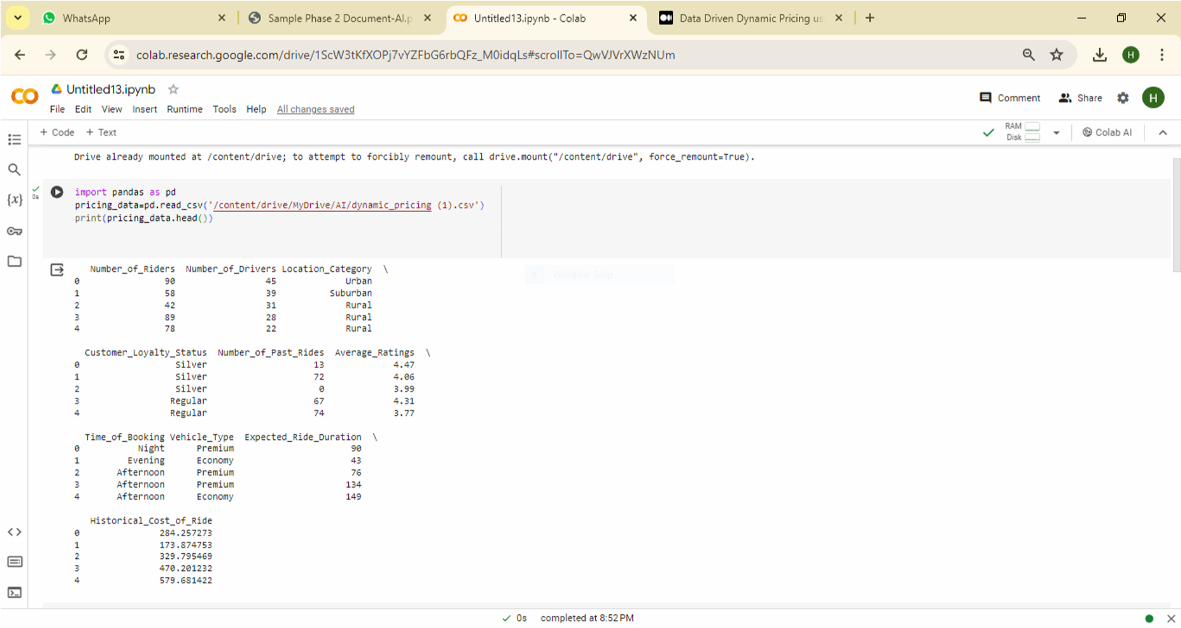

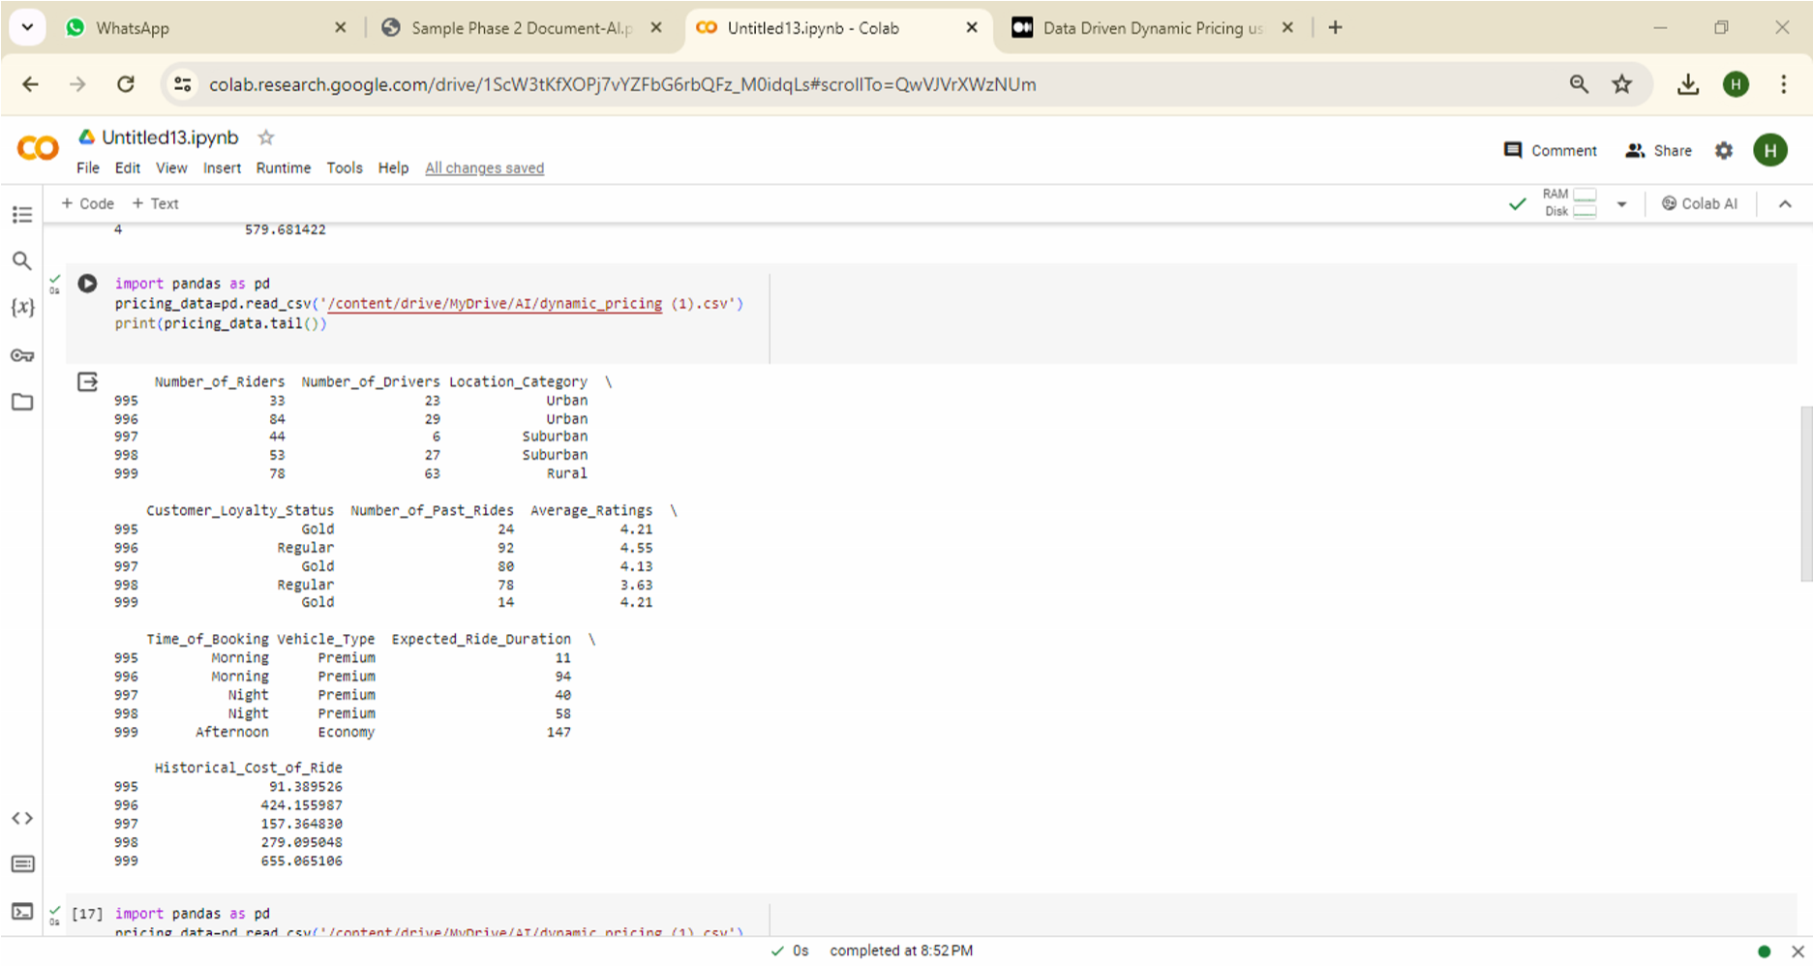

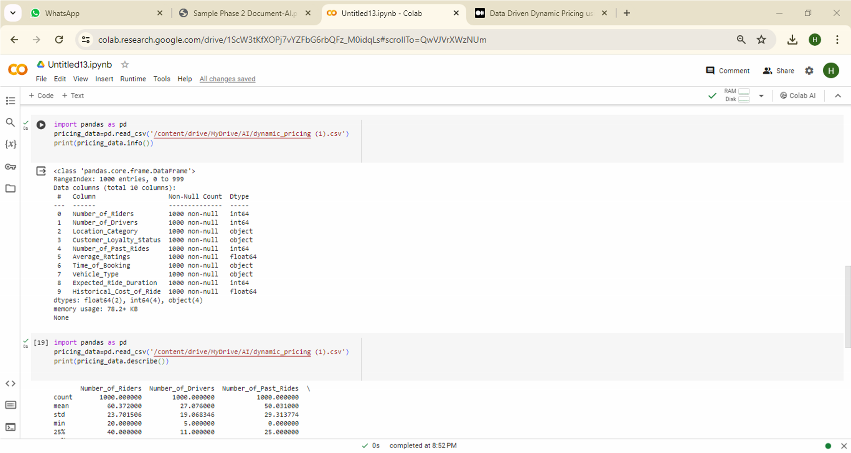

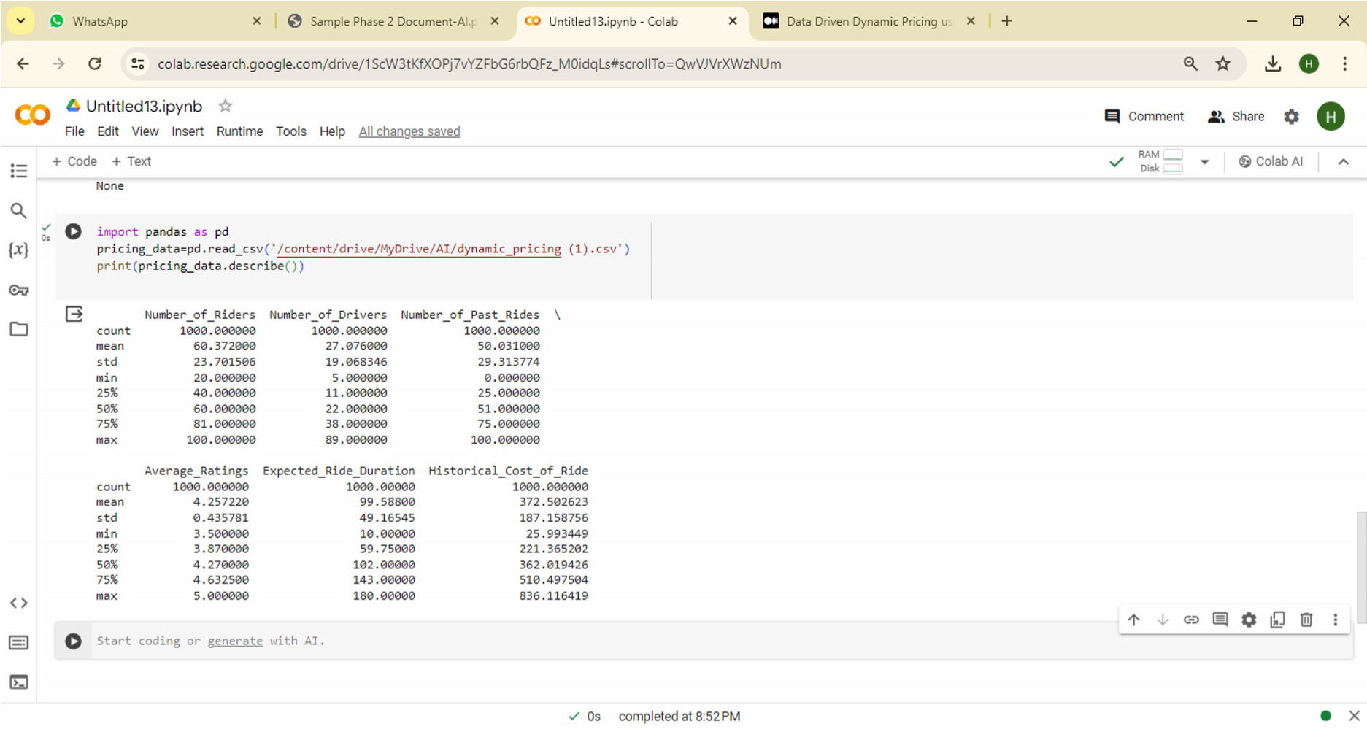

#### 2. Null Data Handling:

The instructions outline a systematic approach to deal with missing data in a dataset:

1. **Null Data Identification:** Identify and locate missing values within the dataset to understand the extent of messiness.
2. **Null Data Imputation:** Fill missing values using suitable strategies such as statistical measures or advanced techniques like interpolation.
3. **Null Data Removal:** Eliminate rows or columns with excessive missing values to maintain data quality and integrity.

These steps help ensure that missing data is managed effectively, minimizing its impact on subsequent analyses or modeling.

##### Python code:

# Sample code for null data handling import pandas as pd pricing_data=pd.read_csv('/content/drive/MyDrive/AI/dynamic_pricing.csv') print(pricing_data.isnull().sum()) pricing_data = pricing_data.dropna() # Drop rows with missing values

##### Output:

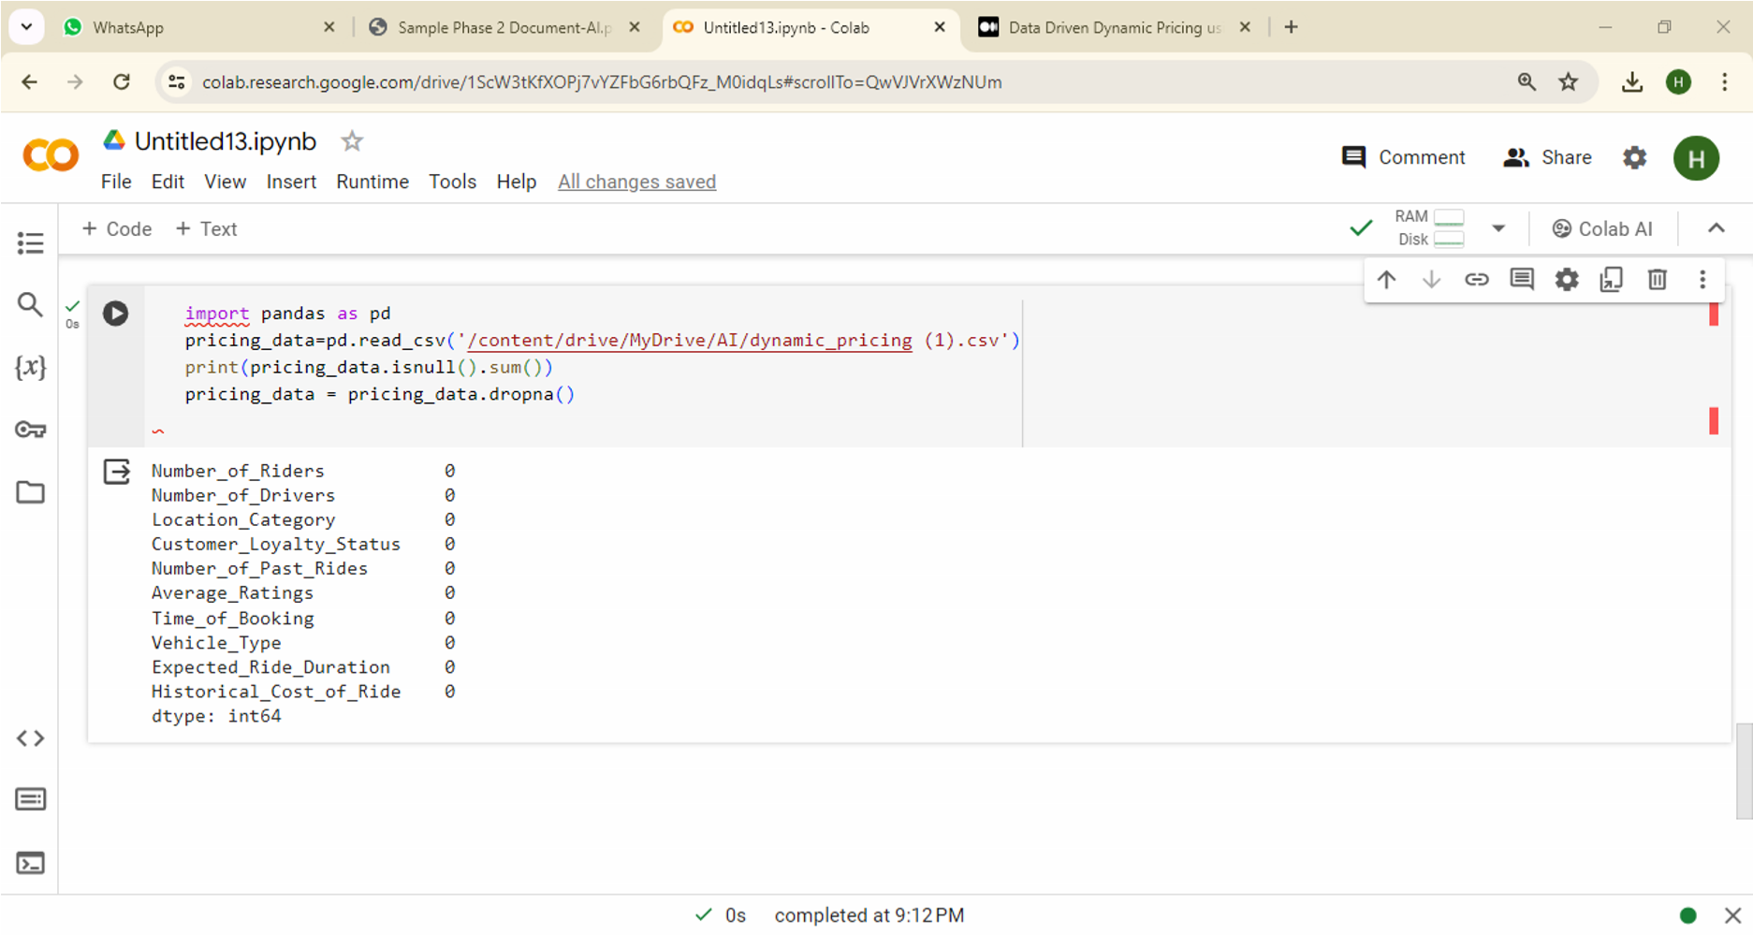

## 3. Data Validation:

**Data Integrity Check:** The instruction underscores the necessity of conducting a data integrity check to ensure the accuracy and reliability of the dataset. This involves verifying data consistency and integrity to identify and rectify errors, ultimately enhancing the dataset's credibility and suitability for analysis or modeling purposes.

##### Python code:

# Sample code for data validation # Check for unique values in a column import pandas as pd

pricing_data=pd.read_csv('/content/drive/MyDrive/AI/dynamic_pricing.csv')

print(pricing_data[‘Vehicle_Type'].unique())

##### Output:

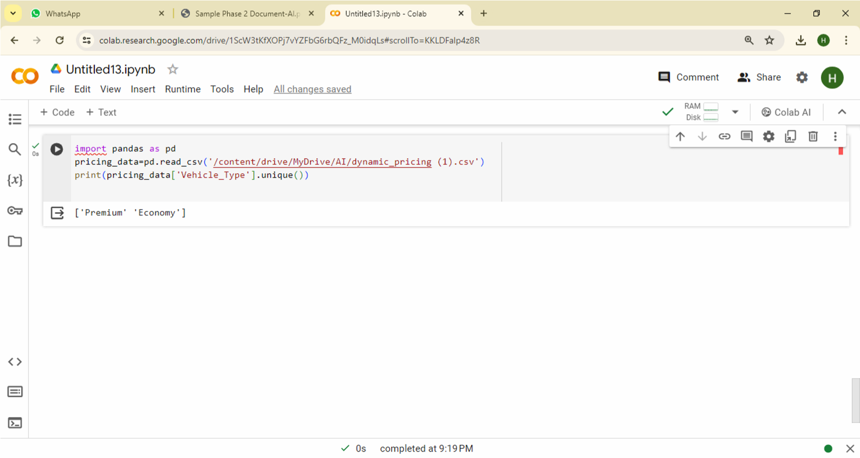

**4. Data Reshaping:**

##### Reshaping Rows and Columns:

The instruction highlights the process of reshaping rows and columns in the pricing data to make it suitable for analysis. This transformation involves restructuring the data into a more organized and informative format that facilitates easier interpretation and analysis. By reshaping rows and columns, analysts can effectively manipulate the data to extract valuable insights and patterns, ultimately aiding in decision-making processes and strategy formulation.

##### Python code:

# Sample code for data reshaping

# Reshape the dataset import pandas as pd

pricing_data=pd.read_csv('/content/drive/MyDrive/AI/dynamic_pricing.csv')

grouped_data = pricing_data.groupby(['Time_of_Booking', 'Vehicle_Type'])

['Number_of_Past_Rides'].mean().unstack() print(grouped_data)

##### Output:

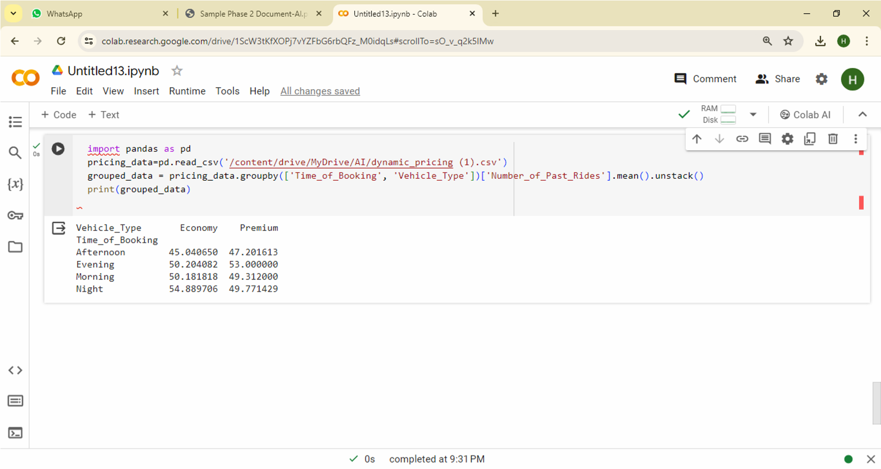

**5. Data Merging:**

##### Combining Datasets:

The instruction underscores the importance of merging multiple datasets or data sources to enrich pricing analysis. By combining diverse sources of data, analysts can create a unified dataset that offers a comprehensive view of pricing-related factors, facilitating deeper insights into market dynamics and consumer behavior. This integrated approach enhances decisionmaking and strategy development in pricing initiatives, ultimately leading to more informed and effective outcomes.

##### Python code:

import pandas as pdcompetitor_pricing_data=pd.read_csv('/content/drive/MyDrive/AI/dynamic.csv') pricing_data=pd.read_csv('/content/drive/MyDrive/AI/dynamic_pricing.csv')

# Sample code for data merging merged_data = pd.merge(pricing_data, competitor_pricing_data,left_on=None) print(merged_data)

##### Output:

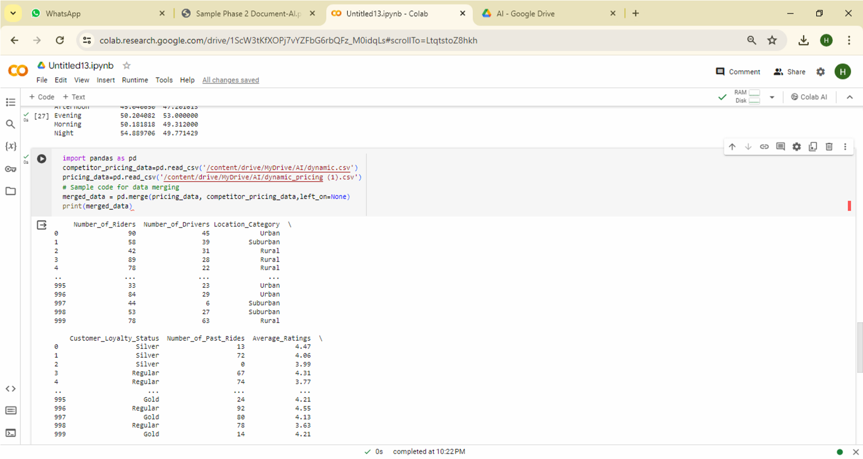

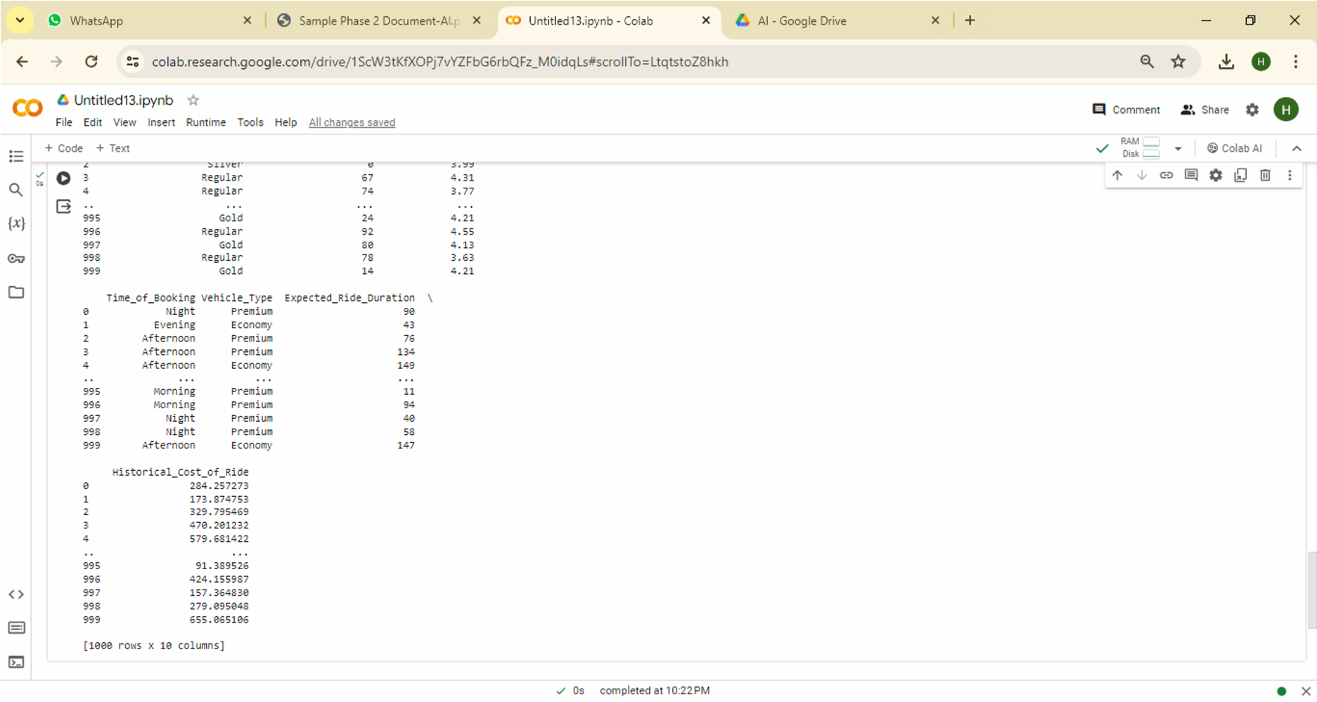

#### 6. Data Aggregation:

The instruction highlights two critical steps in data analysis:

1. **Grouping Data:** This involves organizing pricing data into distinct groups based on specified criteria, such as product categories or time periods. Grouping enables segmentation and facilitates focused analysis on subsets of the dataset.
2. **Aggregating Data:** Once data is grouped, summary statistics like sum, mean, or count are computed for each group. Aggregation condenses the grouped data, providing key insights into overall trends and patterns within each group.

Together, grouping and aggregating data allow analysts to derive meaningful insights from the pricing dataset, aiding in decision-making processes and strategy formulation.

##### Python code:

import pandas as pd pricing_data=pd.read_csv('/content/drive/MyDrive/AI/dynamic_pricing.csv')

# Sample code for data aggregation grouped_data = pricing_data.groupby('Vehicle_Type')

aggregated_data = grouped_data.agg({'Historical_Cost_of_Ride':['mean', 'min', 'max']})

print(aggregated_data)

##### Output:

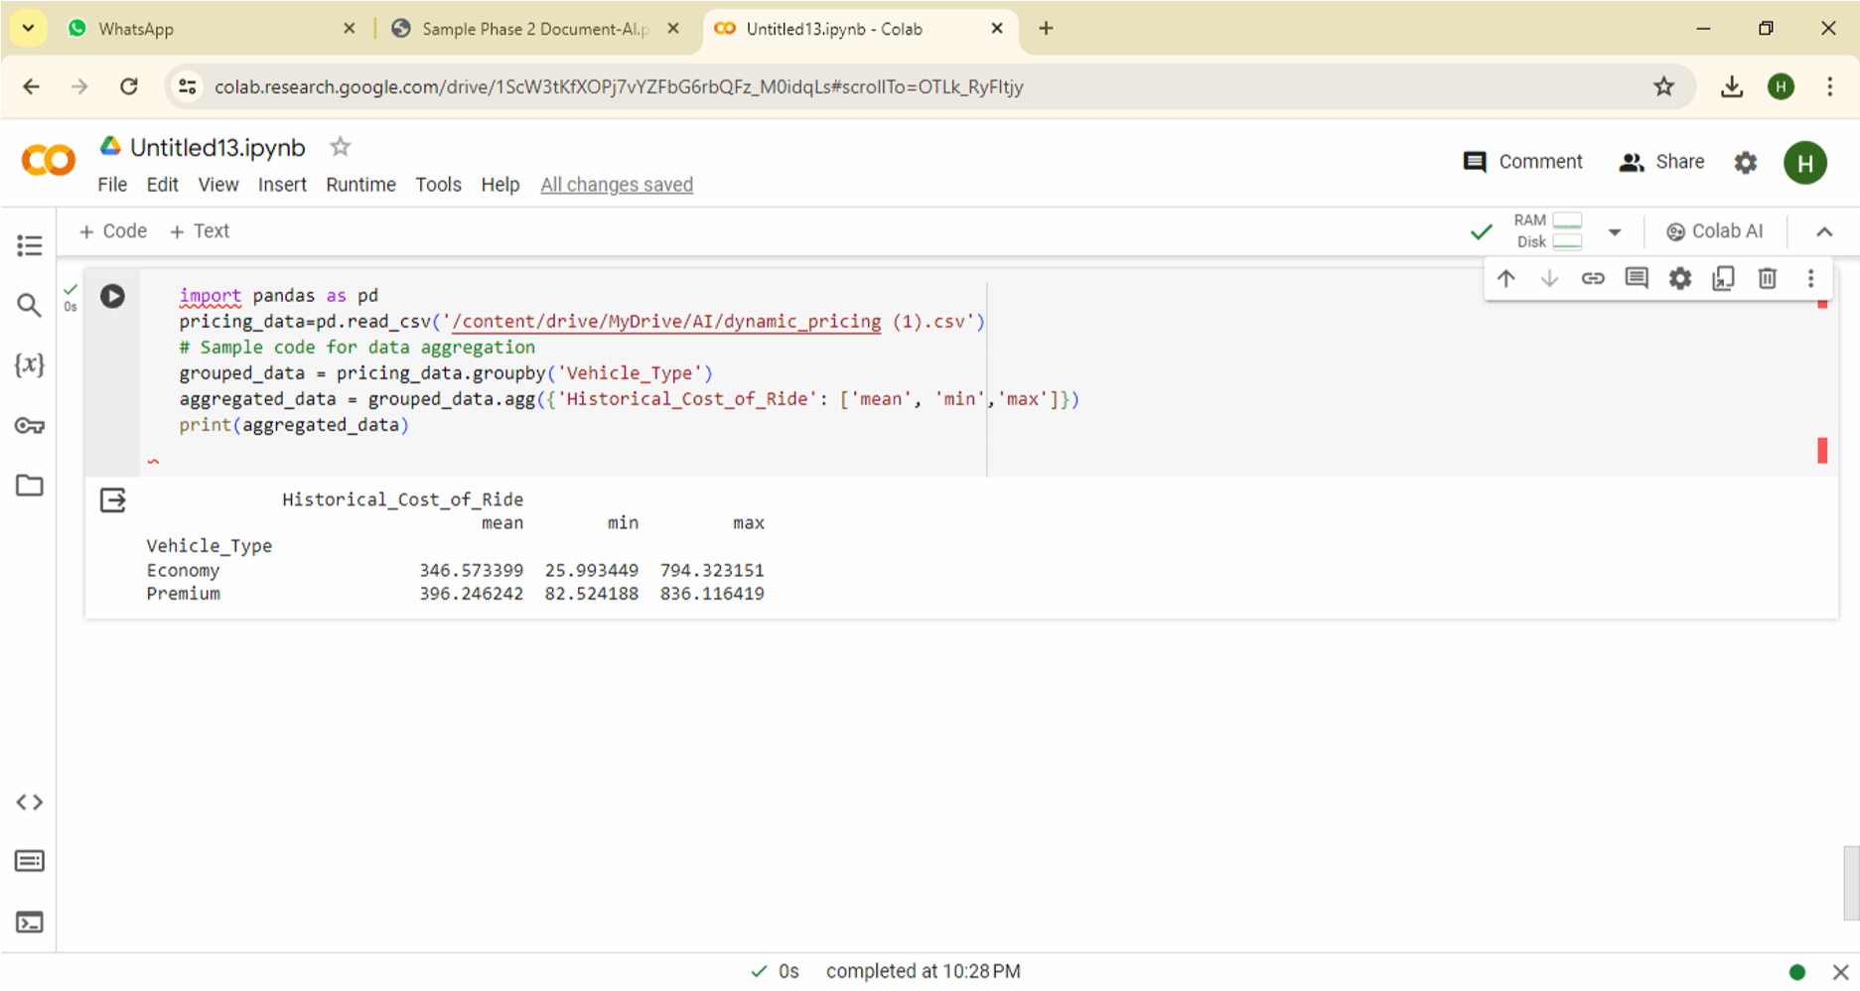

## Dynamic Pricing Analysis Techniques:

**1. Price Distribution Analysis:**

Price Distribution Analysis entails examining how prices are spread across different products within a dataset. This analysis helps in understanding the variability and patterns of pricing within a product portfolio, identifying trends, outliers, and potential pricing strategies. Ultimately, it assists in making informed decisions regarding pricing optimization, market positioning, and revenue management.

##### Python code:

import pandas as pd import matplotlib.pyplot as plt pricing_data=pd.read_csv('/content/drive/MyDrive/AI/dynamic_pricing.csv')

# Sample code for price distribution analysis plt.hist(pricing_data['Historical_Cost_of_Ride'], bins=20)

plt.title('ride cost') plt.xlabel('X') plt.ylabel('Y') plt.show()

##### Output:

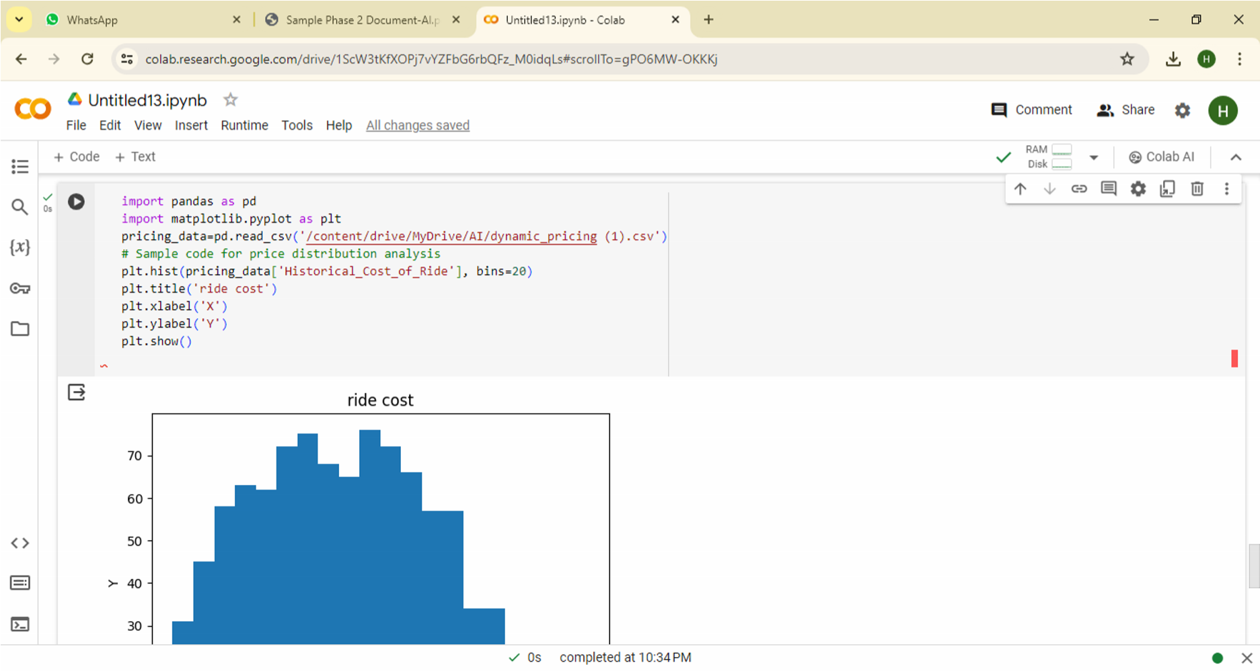

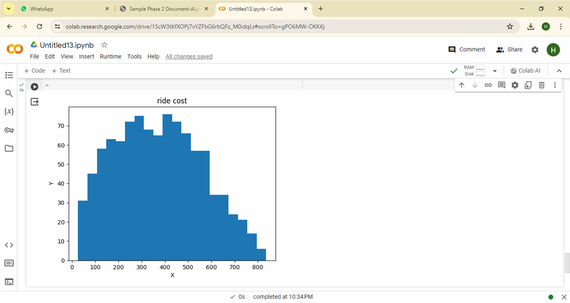

**2. Competitor Price Comparison:**

Comparing our pricing strategy with competitor prices involves assessing our competitiveness and market positioning by analyzing how our prices align with those of competitors. This evaluation helps identify potential adjustments to our pricing strategy, ensuring we remain competitive, attract customers, and maximize revenue while maintaining profitability.

##### Python code:

import pandas as pd import matplotlib.pyplot as plt

# Read the CSV file into a pandas DataFrame pricing_data = pd.read_csv('/content/drive/MyDrive/AI/dynamic_pricing.csv') numeric_data = pd.to_numeric(pricing_data['Number_of_Past_Rides'],

errors='coerce').dropna() # Convert the numeric data to a list y = list(numeric_data) # Create the histogram plt.hist(y, bins=20) # Specify the number of bins (optional) plt.title('Competitor Price Comparison') plt.xlabel('Number of Past Rides') # Update the x-axis label plt.ylabel('Frequency') # Update the y-axis label plt.show()

##### Output:

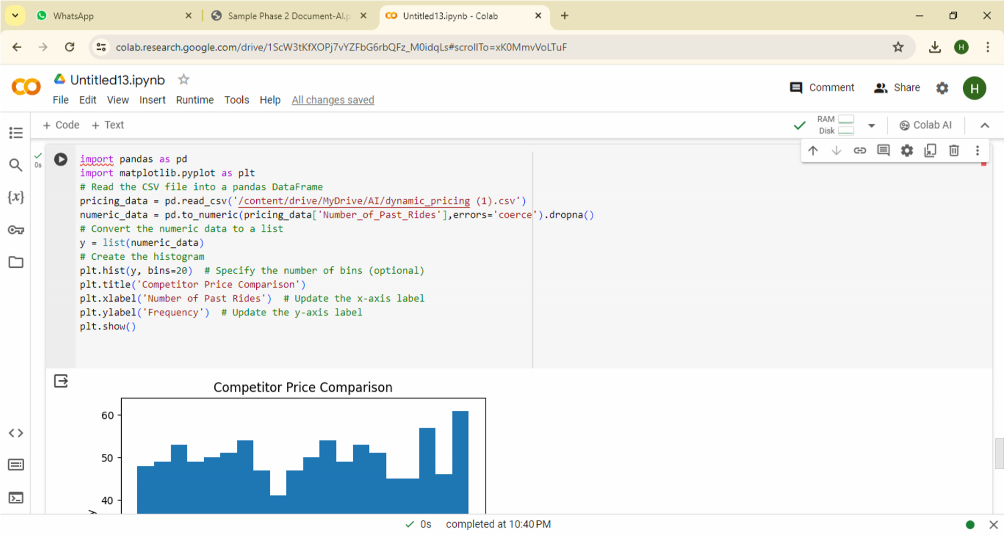

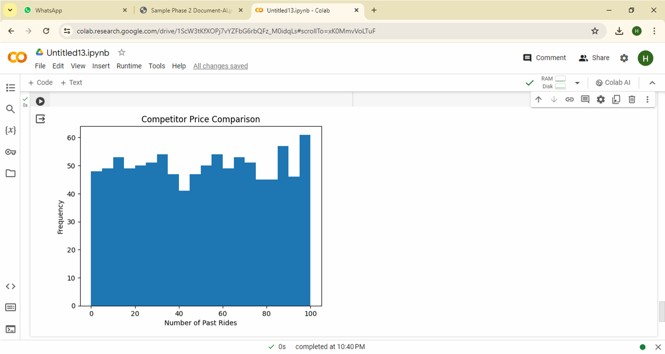

##### 3. Dynamic Pricing Model Performance:

Evaluating the performance of dynamic pricing models entails assessing their effectiveness in predicting and adjusting prices to adapt to market changes. This assessment involves analyzing metrics like revenue growth, profit margins, customer satisfaction, and competitiveness against competitors. By understanding the strengths and weaknesses of these models, we can optimize pricing strategies to achieve desired business outcomes.

##### Python code:

import pandas as pd import matplotlib.pyplot as plt

# Read the CSV file into a pandas DataFrame

model_performance=pd.read_csv('/content/drive/MyDrive/AI/dynamic_pricing.csv')

# Sample code for dynamic pricing model performance evaluation plt.plot(model_performance['Vehicle_Type'], model_performance['Historical_Cost_of_Ride'], label='cost') plt.plot(model_performance['Vehicle_Type'], model_performance['Average_Ratings'],

label='Rating') plt.xlabel('X') plt.ylabel('Y') plt.legend() plt.show()

##### Output:

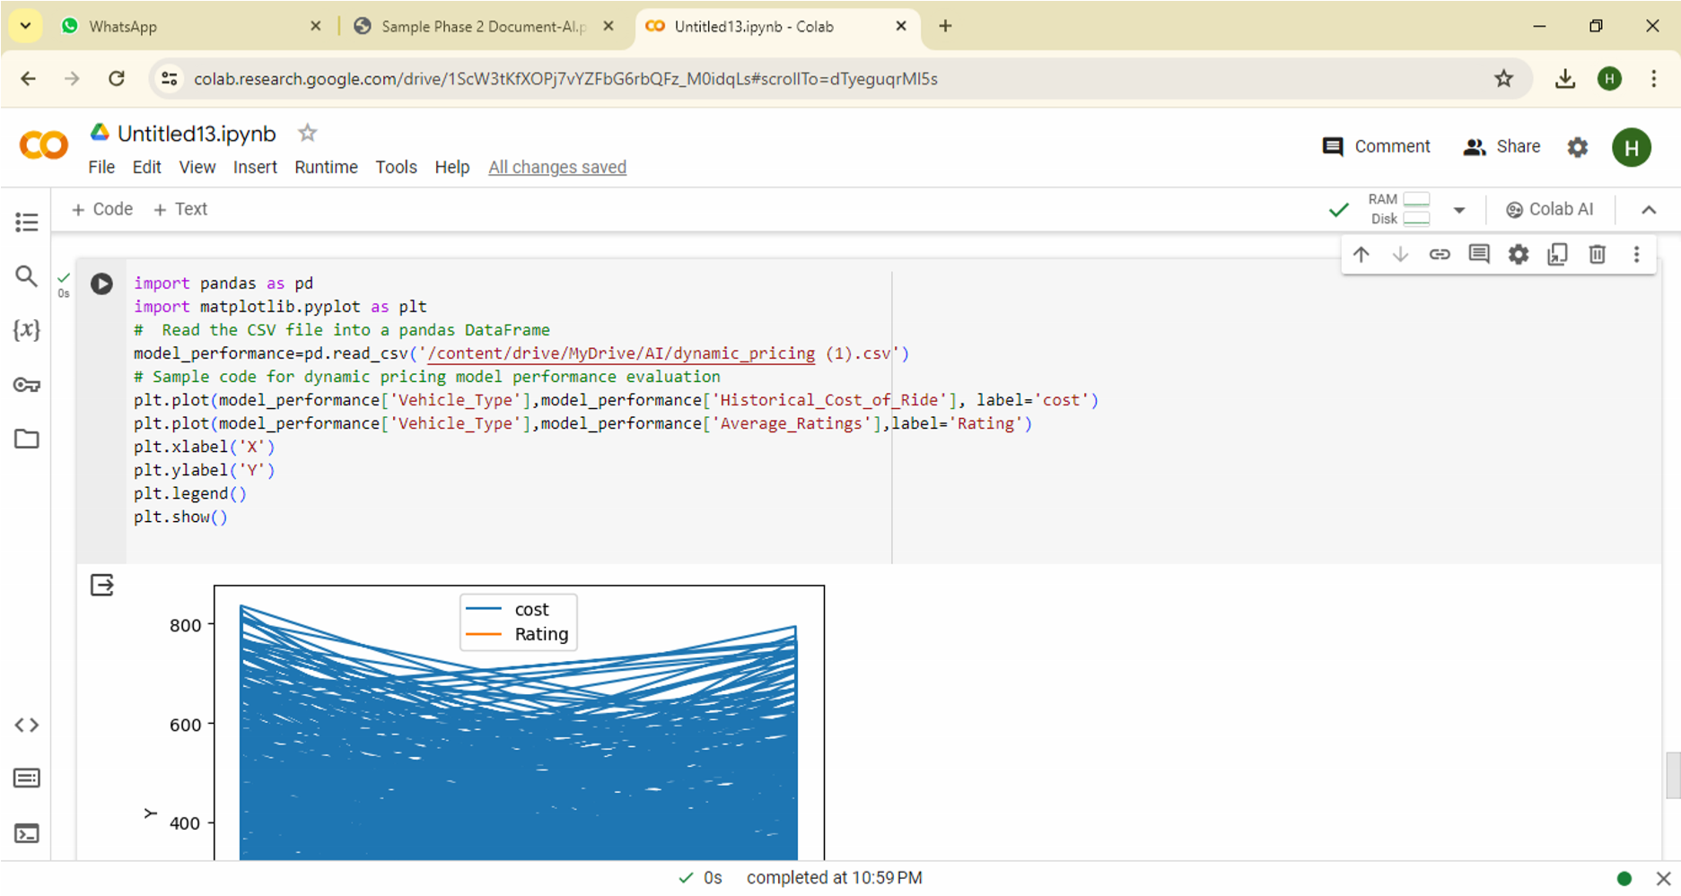

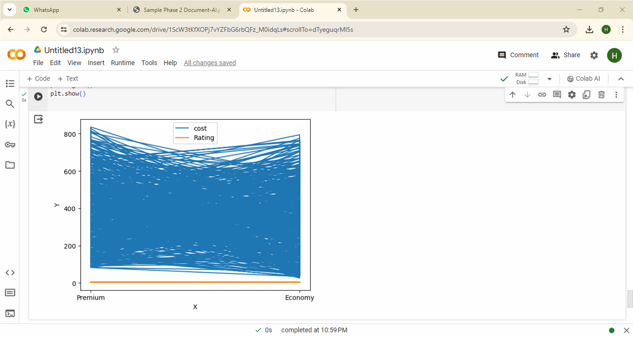

**Exploratory Data Analysis (EDA)**

Exploratory Data Analysis (EDA) is a vital initial step in data analysis. It involves exploring the dataset through visualizations, summary statistics, and hypothesis testing to understand its structure, patterns, and relationships.

**1. Univariate Analysis:**

Univariate Analysis involves studying individual variables to understand their distributions and characteristics. This analysis examines one variable at a time, using descriptive statistics and visualizations to uncover patterns, trends, and outliers. It provides insights into the range, central tendency, and variability of each variable, serving as a foundation for further analysis.

##### Python code:

|  |
| --- |
| import seaborn as sns import matplotlib.pyplot as plt  data=pd.read_csv('/content/drive/MyDrive/AI/dynamic_pricing.csv') sns.histplot(data['Number_of_Past_Rides'], bins=20) plt.show() |

##### Output:

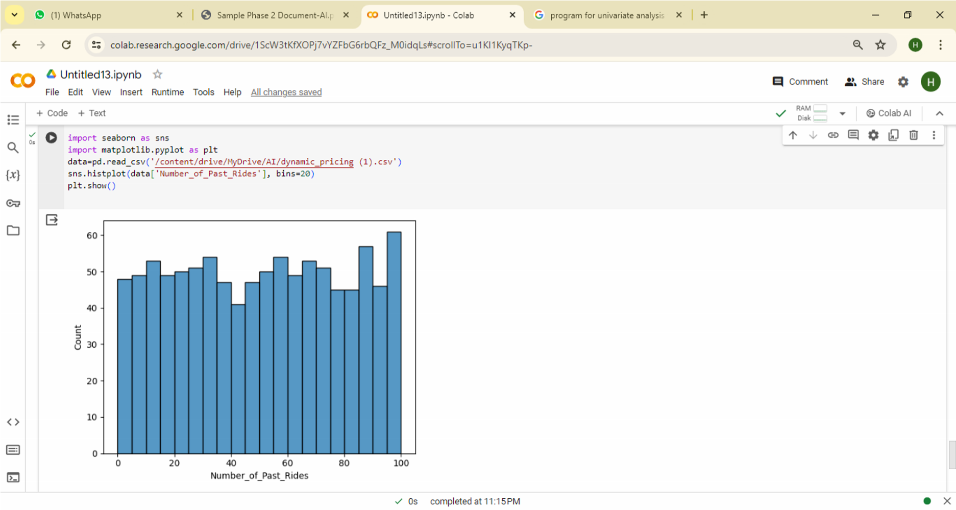

**2. Bivariate Analysis:**

Bivariate Analysis examines the relationship between two variables within a dataset. It helps identify correlations or associations through techniques like scatter plots and correlation coefficients, providing insights into underlying patterns and dynamics in the data.

##### Python code:

|  |
| --- |
| import seaborn as sns import matplotlib.pyplot as plt  data=pd.read_csv('/content/drive/MyDrive/AI/dynamic_pricing.csv') sns.scatterplot(data['Number_of_Drivers']) plt.show() |

##### Output:

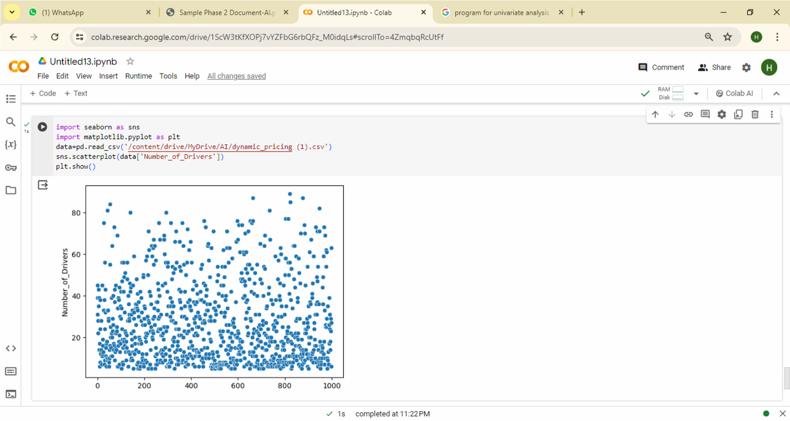

### 3. Multivariate Analysis:

Multivariate Analysis examines the relationships between multiple variables simultaneously, offering a comprehensive understanding of complex patterns within the dataset. It uncovers interactions and dependencies through techniques like regression, principal component analysis, and clustering, enabling deeper insights for decision-making.

##### Python code:

|  |
| --- |
| import seaborn as sns import matplotlib.pyplot as plt  data=pd.read_csv('/content/drive/MyDrive/AI/dynamic_pricing.csv') sns.pairplot(data) plt.show() |

##### Output:

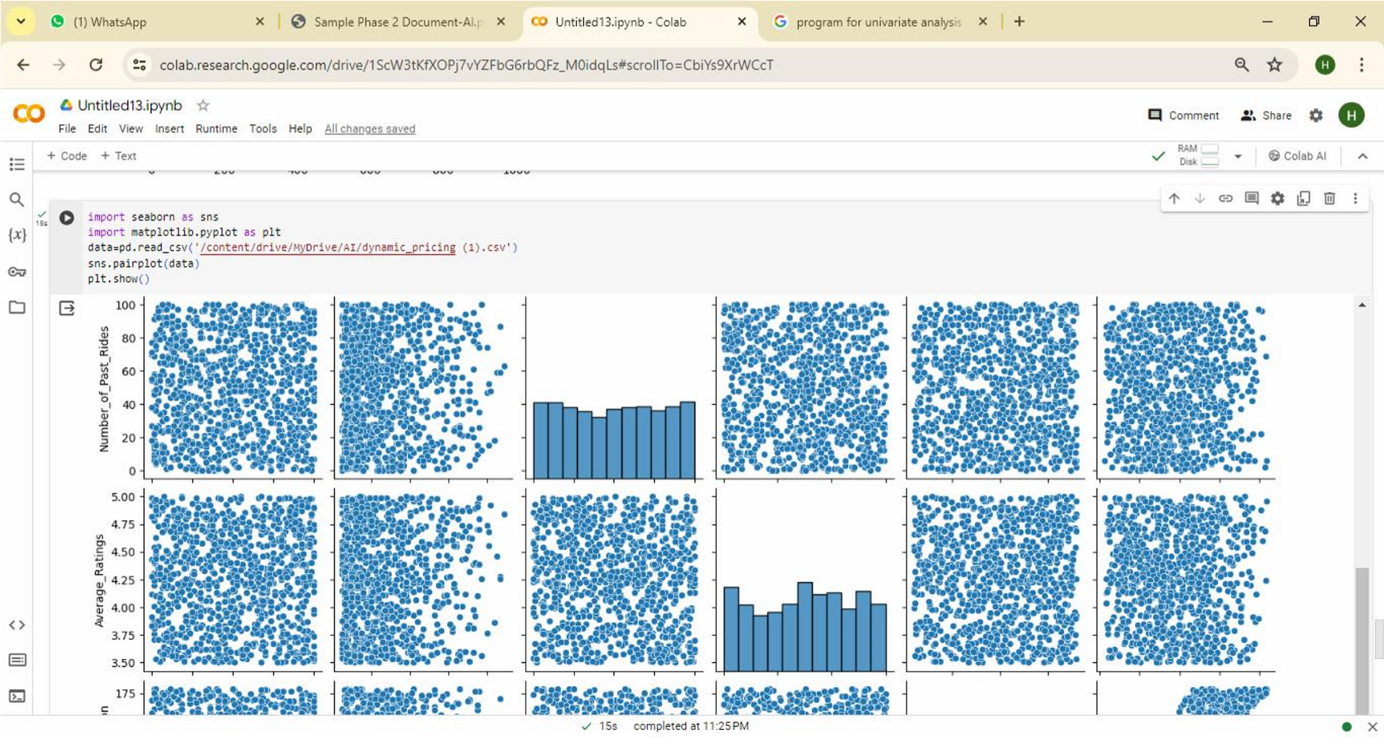

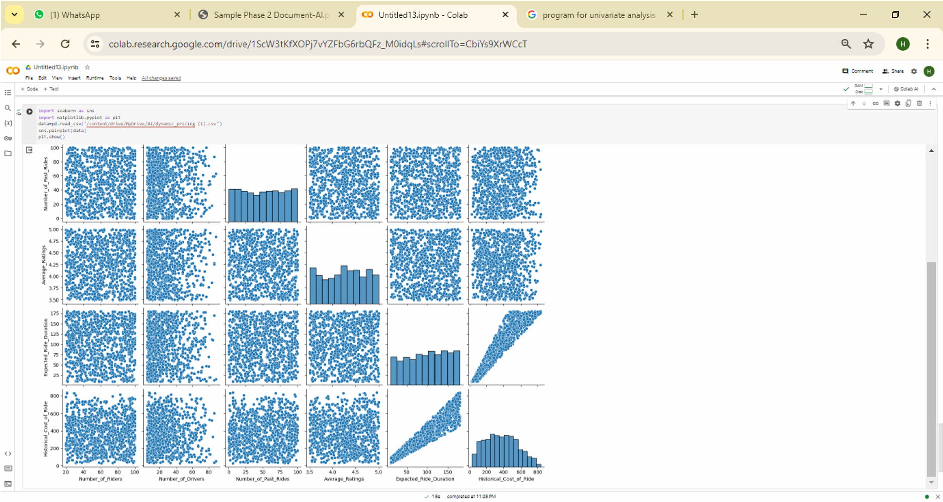

# Assumed Scenario:

**Scenario:** The project seeks to provide personalized content recommendations to users based on their historical interactions and preferences.

**Objective:** The goal is to improve user engagement and satisfaction by delivering relevant and tailored content recommendations.

**Target Audience:** The target audience includes users of digital platforms who are interested in receiving personalized content recommendations across various domains.

## Conclusion:

In conclusion, dynamic pricing offers businesses the ability to adapt pricing strategies in real-time, maximizing revenue and competitiveness. However, successful implementation requires careful consideration of factors like data quality, algorithm selection, and ethical considerations. With ongoing monitoring and optimization, businesses can leverage dynamic pricing to stay competitive, responsive, and deliver value to customers.